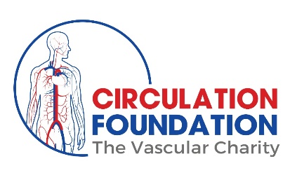
Volunteer Ambassador application
– Patient representative

Role title: Circulation Foundation Ambassador – Volunteer role
Hours: This is a flexible role dependant on available time
Reports to: Ambassador Manager - info@circulationfoundation.org.uk
Scheme administrators: Executive Business Supports (EBS)
Website: www.circulationfoundation.org.uk

ABOUT CIRCULATION FOUNDATION

The Circulation Foundation is the only UK Vascular charity, dedicated to vascular health.

Our Vision: - a society free of vascular disease, and its associated suffering.
Our Mission: - promote awareness into Vascular conditions and to support vital research.

Vascular Disease is as common as cancer and heart disease and accounts for 40% of deaths in the UK. We promote our Awareness programmes nationally focussing on providing better information and support for patients and carers. We also aim to create a better understanding of the importance of healthy arteries and veins, and how this can be easily achieved leading to longer, healthier lives.

The Circulation Foundation has created a structured research programme aimed at preventing vascular disease, advancing and discovering new treatments and improving patient care.

We are fortunate that today there is an explosion of scientific knowledge and state-of-the-art technologies available. However, our patients to benefit from the innovations we need to raise money!

The Circulation Foundation was established in 1992 by vascular surgeons committed to eradicating vascular disease. It is the charitable foundation of the Vascular Society of Great Britain and Ireland, managed by a committee, which are accountable to the Trustees of the Vascular Society of Great Britain and Ireland.

Charity Number: 1102769

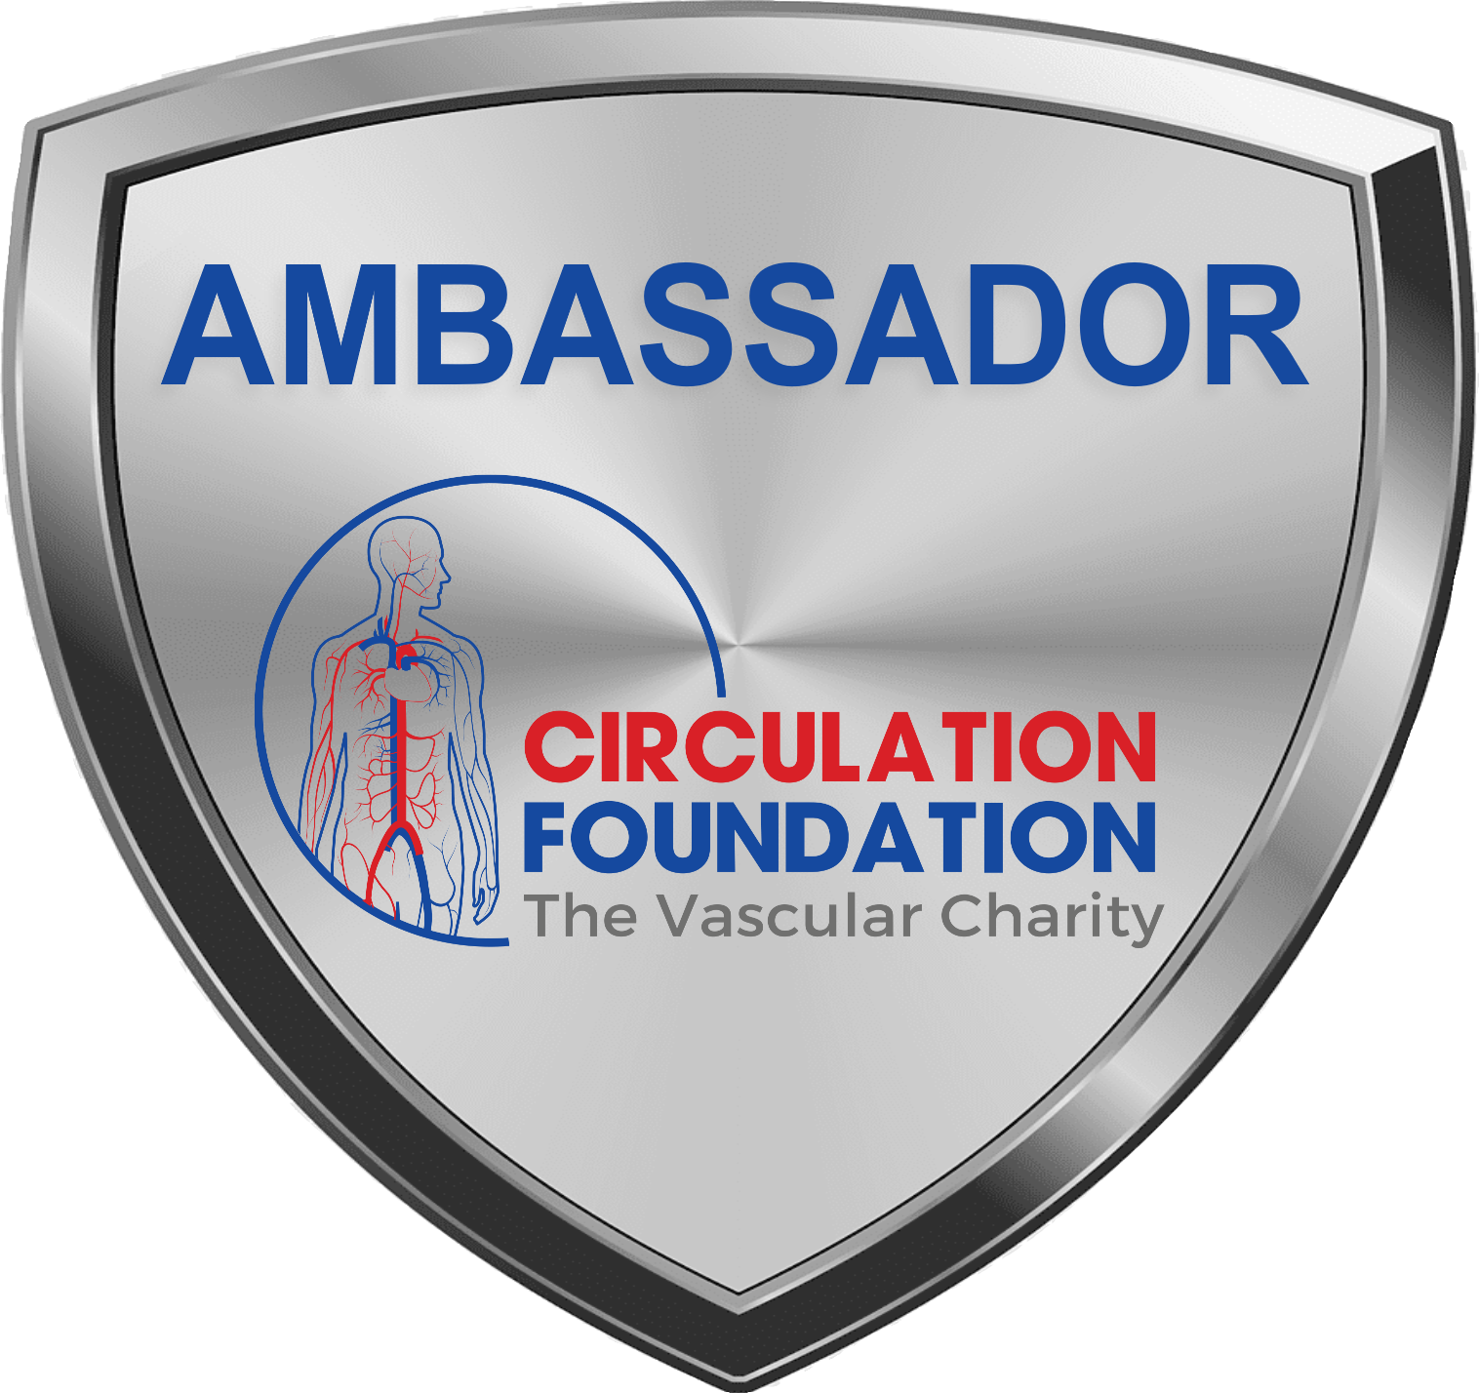OVERVIEW OF THE AMBASSADOR SCHEME
Our goal is to establish a Circulation Foundation Network by having an Ambassador in each Arterial Centre across the UK and patient representatives providing a patient voice. We would then be able to work together to increase awareness of vascular conditions, share and repeat fundraising success, increase our research grants and make the CF the support centre for patients.
THE ROLE
The role of Ambassador will be to promote the Circulation Foundation by:
- Helping to promote appeals.
- Encourage local fundraising.
- Sharing posts and promoting Circulation Foundation on social media.
- Take part in national initiatives such as Vascular Awareness Month.
- Find out how the CF can support patients and raise awareness of vascular disease.
SKILLS AND EXPERTISE
- Passion for the work of Circulation Foundation and raising awareness of vascular disease.
- A great communicator, friendly and approachable.
- Ability to work on your own initiative or as part of a team.
- Good organisational skills and accuracy.
- Be knowledgeable of data protection laws regarding personal data.

BENEFITS
- Make a real difference to the lives of people who are affected by vascular disease.
- Help to raise awareness of vascular disease.
- Learn new skills.
- Be able to network with like-minded people.
- Give something back to the vascular community.
- Be part of a professional and committed charity and a valued member of the team.
- Recognition on social media, newsletter and on the website.
- Special recognitions at the Annual Scientific Meeting.

APPLICATION PROCESS
Before applying, please read our Privacy policy and Social media policy here. If you have any questions regarding our policies and how they may affect you, please email info@circulationfoundation.org.uk.
Please fill in the attached application form and email to info@circulationfoundation.org.uk.
Your details and application will then be forwarded onto the Circulation Foundation Committee and the outcome of your application will be emailed to you as soon as possible.
All new Circulation Foundation Ambassadors will receive an Ambassador pack to get you started.

QUESTIONS
If you have any questions about the Ambassador scheme, please contact us by emailing info@circulationfoundation.org.uk.

Volunteer Ambassador application
– Patient representative
This volunteer agreement is made in good faith between you and the Circulation Foundation on the basis that you are a volunteer, not an employee. If you or the Circulation Foundation wish to end this volunteer agreement, this can be done at any time.
SECTION 1: Your details
First name
Last name
Contact number
Email address
City/town
County
What best describes you? | ☐ Patient  ☐ Carer or family member of a patient  ☐ Fundraiser  ☐ Other (please describe):

SECTION 2: Guidelines
      - to perform your volunteering within the boundaries of your role and to the best of your ability
      - to present yourself in a professional manner to members of the public, patients, families and members of staff and to adhere to the charity values and respect equality and diversity
      - to ask for help if needed and raise any problems relating to volunteering activity directly to the Ambassador Manager
      - to maintain confidential information of the Circulation Foundation and of its patients at all times in accordance with the GDPR act 2018
      - to not contact the press or reply to press enquiries without prior consent from the Circulation Foundation
      - to ensure that the information and opinions you share on social media protects the Circulation Foundation’s reputation and are not in conflict with our brand, guidelines and policies or could bring the charity into disrepute
Thank you for taking note of these guidelines.
SECTION 2: Data Protection
You may come into contact with a wide variety of personal data during your volunteering. The most important thing to remember is that this information is confidential and you must not share any details that could be used to identify an individual.
The Circulation Foundation take data protection extremely seriously. Our policies can be found here - https://www.circulationfoundation.org.uk/privacy-policy.
If you have any questions about data protection and how this may affect how you work on behalf of Circulation Foundation, please contact info@circulationfoundation.org.uk.
Please confirm you have read and understand the following policies:
☐ Privacy policy
☐ Social media policy
☐ Retention policy
If you feel you may have a conflict of interest, please let us know when you send your application.
Applicant signature Date
If you have any problems filling in this application, please call on 020 7205 7151.
Please fill in this form and either email to info@circulationfoundation.org.uk or post to:
Circulation Foundation, c/o EBS, City Wharf, Davidson Road, Lichfield, Staffordshire, WS14 9DZ.
Please fill in this form and either email to info@circulationfoundation.org.uk or post to:
Circulation Foundation, c/o EBS, City Wharf, Davidson Road, Lichfield, Staffordshire, WS14 9DZ.

