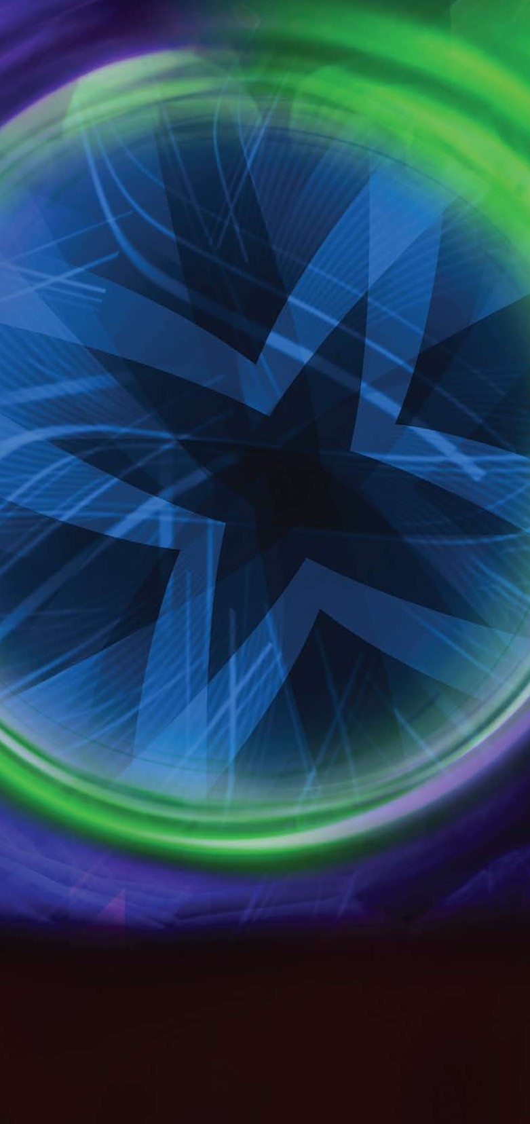

**Nerve damage:** As nerves can lie alongside the veins these may also become damaged by the heat or by avulsions and a few patients notice small patches of numbness on their skin. These usually resolve over a few months.

**Burns:** Although it is possible to burn the skin with the laser in practice this is very rare indeed.

**DVT:** A DVT is a blood clot in the deep veins in the leg. It is a recognised complication of surgery and can be dangerous if the clot breaks away and travels to the lungs. The risk of getting a DVT after EVLA is very low but has been reported.

# Which procedure is right for me?

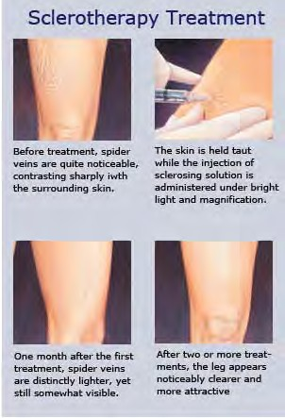Many patients considering EVLA are confused as to which treatment to go for. This is unsurprising as there are several options including doing nothing, having an operation and several new non surgical treatments like Foam Sclerotherapy,

RFA (VNUS) and EVLA.

Much will depend on the experience of your vascular specialist. Some surgeons still only undertake surgery but most now offer at least one of the new treatment options.

Doing nothing is a good option if you are not bothered by the

appearance of your veins and they are not causing significant symptoms. There is no medical need to treat most varicose veins.

Wearing stockings is a good option for those with symptoms but who are not worried about the appearance of their legs and are willing to wear stockings for the rest of their lives.

Surgery is rarely required but still preferred by some patients especially those who wish to have a general anaesthetic, those who don’t like injections and those with extensive varicose veins on both legs who want all treatment carried out in one session.

If you want definitive treatment but want to avoid surgery and general anaesthesia and to get back to normal activities quickly you should consider one of the following treatments.

**Foam sclerotherapy** is good especially for those with less extensive veins who are willing to accept the possible need for several sessions of treatment and the possibility of the veins recurring in the future and further treatment becoming necessary. It is the least invasive option.

**RFA (VNUS, RFITT)** is good for those with a long wide straight segment of vein which requires treating.

Approximately 70% of patients are suitable for RFA.

**EVLA** is suitable for almost all patients however short or wide their veins are.The method and results of treatment are almost identical with RFA and EVLA.

N.B. Foam sclerotherapy, RFA and EVLA all require at least two treatment sessions in most patients. Expect it to take at least 8 weeks to see the full effect of treatment. Look at the information about all the different options and ask your specialist’s advice before coming to a decision about which

treatment is right for you.

Whilst we make every effort to ensure that the information contained in this patient information sheet is accurate, it is not a substitute for medical advice or treatment, and the Circulation Foundation recommends consultation with your doctor or health care professional. The information provided is intended to support patients, not provide personal medical advice. The Circulation Foundation cannot accept liability for any loss or damage resulting from any inaccuracy in this information or third party information such as information on websites to which we link.

Circulation Foundation

Blackburn House, Redhouse Road, Seafield, West Lothian EH47 7AQ T: 020 7205 7151

E: [info@circulationfoundation.org.uk](mailto:info@circulationfoundation.org.uk)

circulationfoundation.org.uk

The Circulation Foundation is an operating division of the Vascular Society, a charitable company limited by guarantee, company number 5060866 and registered charity number 1102769

PATIENT INFORMATION

VARICOSE VEINS

**ENDOVENOUS LASER ABLATION THERAPY**

Vascular disease is as common as both cancer and heart disease and accounts for **40% of deaths in the UK**, many of which are preventable.

**SAVING LIVES AND LIMBS**

**circulationfoundation.org.uk**

**Endovenous laser ablation** goes under several names eg. **EVLT, ELVes, VeinSeal** depending on the manufacturer of the laser. We use the general term **EVLA** for Endovenous Laser Ablation as all the various types of laser ablation are essentially the same.

We’re serious about saving lives. But this won’t happen without generous donations from people like you.

To make a donation, please visit circulationfoundation.org.uk or to discuss a major donation, legacy or corporate support, please call 020 7304 4779

# What is EVLA?

EVLA is a new method of treating varicose veins without surgery. Instead of tying and removing the abnormal veins they are heated by a laser. The heat kills the walls of the veins and the body then naturally absorbs the dead tissue and the abnormal veins are destroyed. It can be carried out in a simple treatment room rather than an operating theatre.

# Are my veins suitable for EVLA?

Almost all patients with varicose veins are suitable for EVLA. Those few who are not suitable (usually those with small recurrent veins after previous surgery) can usually be managed with just foam sclerotherapy (injection treatments).

# What does the procedure involve?

An ultrasound scan is performed and the veins to be treated are marked with a pen. You lie on a couch and your leg is cleaned and covered with drapes.

Depending on which veins are to be treated you may be on your back or your front. All these steps are guided by ultrasound

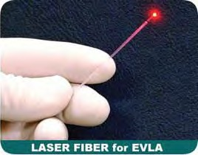scanning.

Endovenous means inside the vein so the next thing the doctor has to do

is to get inside your vein. A small amount of local anaesthetic is

injected into the skin over the vein and

a needle inserted into it. A wire is passed through the needle and up the vein. The needle is removed and a catheter (thin plastic tubing) is passed over the wire, up the vein and the wire removed.

A laser fibre is passed up the catheter so its tip lies at the highest point to be heated (usually your groin crease).

A large quantity of local anaesthetic solution is then injected around the vein through multiple tiny needle pricks. All staff and the patient put on laser safety glasses as a precaution.

The laser is then fired up and pulled down the vein over about 5 minutes. You will hear a warning buzzer ringing and may smell or taste burning but won’t feel any pain.

If you’re having both legs treated the process is repeated on the other leg. The laser and catheter are removed and the needle puncture covered with a small dressing.

The treatment takes about 20-30 minutes per leg. You may also have some foam sclerotherapy or some veins removed and a compression stocking is then put on.

# What happens after treatment?

Soon after your treatment you will be allowed home.

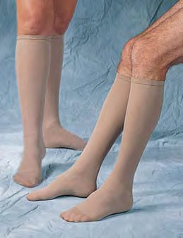It is advisable not to drive but to take public transport, walk or have a friend drive you. You will have to wear the stockings for up to two weeks and you will be given instructions about how to bathe.

You should be able to go back to work straight away and get on with most normal activities.

You cannot swim or get your legs wet while in the

period during which you have been advised to wear the stockings.

Most patients experience a tightening sensation along the length of the treated vein and some get pain in that area around 5 days later but this is usually mild. Normal anti-inflammatory drugs like Ibuprofen are normally sufficient to relieve it.

# Are all lasers the same?

Most of the lasers used for EVLA are almost identical. Some new types claim to cause less pain than the standard lasers. There does appear to be some truth in this although the degree of pain experienced by most patients with standard lasers is minimal and easily tolerated. The new lasers have not undergone the same extensive clinical testing and therefore we don’t know for certain if they will be as effective especially in the longer term.

# Will I need further treatment?

If you are having treatment just to relieve symptoms then no further treatment is usually necessary. Most patients however wish also to improve the appearance of their veins and of these about 80% will require further treatment. The varicosities normally become less obvious after EVLA but rarely disappear completely. Additional treatment for the

varicosities can be either by avulsions or foam sclerotherapy.

These additional treatments can be undertaken at the time of the EVLA or more usually after a delay of 4-6 weeks. If you have extensive varicose veins on both legs it is very unlikely that you will be able to have all the additional treatment undertaken at the time of the EVLA.

Vein removal is undertaken after local anaesthetic solution has been injected around the veins to numb the area. Small incisions are made over the veins and they are teased out with a crochet hook. You may require many small incisions but they heal easily without stitches and with minimal scarring.

Foam sclerotherapy is the most common way of dealing with residual varicose veins after EVLA and is highly effective for these.

# What are the complications?

Serious complications after EVLA are very rare.

**Thrombophlebitis:** EVLA works by heating the wall of the vein and an inevitable and deliberate response to the heat is an inflammation of the vein wall. You may feel the vein that has been treated become hard and tender. Varicose veins that feed from the treated vein may also become hard and lumpy as some blood clot forms within them. This clot is not dangerous and your body will naturally absorb it over a few weeks.