Occasionally, usually when there is inflammation, the leg will be painful. The pain may last for up to three weeks in this situation.

Regular daily exercise such as going for a walk or using an exercise bike to provide a gradual return to normal activity is recommended.

To rest up after the operation raises the risk of developing blood clots in the deep veins (deep vein thrombosis or DVT). Regular exercise reduces this risk, but makes the leg more uncomfortable.

# Complications

**Nerve injuries:** These are uncommon occurring in about 1 in 20 cases. Two skin nerves are particularly at risk. The first picks up sensation from the top of the foot, and the second from the outer border of the foot. Other unnamed nerves may also sometimes be damaged leading to reduced sensation anywhere in the leg. The reduced sensation may be very noticeable at first, but normally diminishes with time, and is not usually a problem in the longer term.

**Deep Vein Thrombosis:** DVT complicates any operation from time to time. It also occurs occasionally following varicose vein surgery. Patients with extensive varicose veins associated with skin changes are probably at the greatest risk, but the complication is rare.

**Recurrent Varicose Veins:** Recurrence of varicose veins occurs in about 1 in 15 patients over a ten-year period. Sometimes further treatment may be required.

# What can I do to help myself?

When you get home, try to return to normal as soon as possible. The more exercise you take, the more sore your leg will be, but the quicker the leg will return to normal.

If you have further questions, please do not hesitate to ask either your Consultant or one of his team, or the Nurses who are looking after you on the ward.

Whilst we make every effort to ensure that the information contained in this patient information sheet is accurate, it is not a substitute for medical advice or treatment, and the Circulation Foundation recommends consultation with your doctor or health care professional. The information provided is intended to support patients, not provide personal medical advice. The Circulation Foundation cannot accept liability for any loss or damage resulting from any inaccuracy in this information or third party information such as information on websites to which we link.

PATIENT INFORMATION

VARICOSE VEINS

**THE OPERATION**

Circulation Foundation

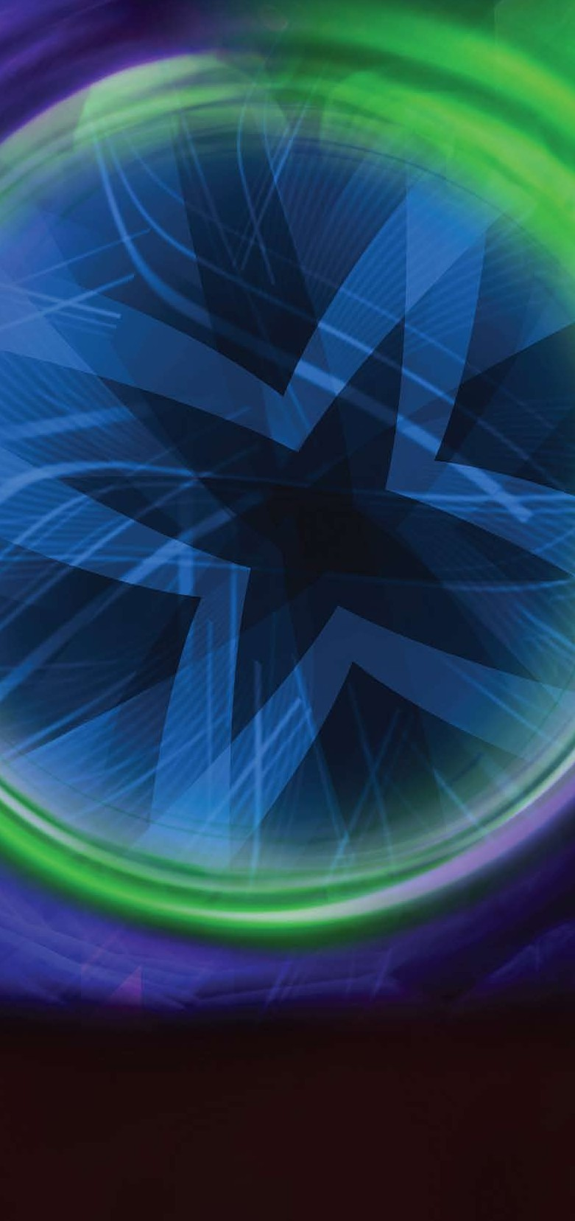

Blackburn House, Redhouse Road, Seafield, West Lothian EH47 7AQ T: 020 7205 7151

E: [info@circulationfoundation.org.uk](mailto:info@circulationfoundation.org.uk)

circulationfoundation.org.uk

The Circulation Foundation is an operating division of the Vascular Society, a charitable company limited by guarantee, company number 5060866 and registered charity number 1102769

Vascular disease is as common as both cancer and heart disease and accounts for **40% of deaths in the UK**, many of which are preventable.

**SAVING LIVES AND LIMBS**

**circulationfoundation.org.uk**

The following information deals with the operation for varicose veins.

We’re serious about saving lives. But this won’t happen without generous donations from people like you.

To make a donation, please visit circulationfoundation.org.uk or to discuss a major donation, legacy or corporate support, please call 020 7304 4779

The damaged valves in the veins cannot be cured so the best way to cure the problem is to remove the affected veins.

The aim of surgery is to take pressure off the skin veins in the leg, by tying and dividing (and often removing) the principal skin veins in the leg.

The removal of varicose veins does not affect blood flow because other veins and especially the deep veins take over this job.

# The operation is particularly suitable for people with:

* Ulceration, or threat of ulceration resulting from their varicose veins.
* If the veins have caused bleeding through the skin. This is frightening, and may recur.
* Phlebitis (inflammation in the veins and overlying skin), large varicose veins and aching in the veins.

The aims of surgery are to reduce to normal the pressure in the skin veins.

This will prevent existing varicose veins from enlarging further, and will prevent new varicose veins from growing.

For those with skin changes around the ankles or previous ulceration, reducing the pressure prevents worsening of the skin change and usually reduces the risk of further ulceration. For this group, the addition of support stockings further protects the skin around the ankles.

# The operation

Before varicose vein surgery, there are a number of tests that need to be done. These will always include examination with handheld Doppler, and may include an ultrasound scan.

Varicose vein surgery is often performed as a Day Case. If you are fit, have a family member to take you home, and be with you over night, you will probably qualify. Those having more complex surgery and those who live alone will stay in hospital overnight.

The Surgeon who will be performing your operation will visit you immediately before the procedure. He will mark up your veins with a waterproof pen, agreeing with you which veins will be removed. You should ensure that all your varicose veins are marked.

Varicose vein surgery is performed under general anaesthetic.

The operation varies a little from case to case, depending on where the leaky valves are.

Normally you will have a slanting cut about 4-6cm long running in the skin crease of the groin.

Through this incision the top end of the faulty skin vein (long saphenous vein) is tied off to stop blood flowing through it. A wire is then inserted into the vein and passed down to knee level.

At knee level a second cut is made and the vein (with the wire running through it) is pulled out. This procedure is called stripping.

The tying and removal of the long saphenous vein deals with the cause of the varicose veins and should prevent them coming back.

Less frequently, when the principal vein on the back of the knee has a leaking valve, it too needs ligation. This is performed through a horizontal incision about 3cm long on the back of the knee. The vein is then removed as before.

The short saphenous vein is rarely stripped from the leg because it lies close to a nerve, picking up skin sensation, which may be damaged.

Finally, in most cases, the visible varicose veins are removed from the leg through tiny incisions about 2-3mm in length. Incisions are placed about 3-5cm apart along the line of the varicose vein. There may be a large number of tiny incisions if the varicose veins are extensive.

The larger incisions are closed with a stitch, which lies beneath the skin and doesn’t need to be removed. The leg is bandaged firmly from toe to groin at the end of the operation.

# After the treatment

You will usually be taken to the Theatre Recovery area after the operation, where you will wake up. When you are fully awake (usually 20-30 minutes) you will return to the ward. Most people describe the leg as stinging or burning when they wake up. It is unusual for the leg to be painful.

Some of the smaller incisions may bleed a little over the first 24-48 hours. For this reason, it is best to keep the leg covered with bandages or stockings for the first 48 hours.

After this time, the stockings may provide support and make the leg more comfortable. They may be worn for up to 10 days, but do not usually help beyond this time.

The incisions, although initially very visible, will reduce to become virtually invisible within 9-12 months. There is usually extensive bruising in the leg, particularly down the inside of the thigh. This bruising usually lasts for 3-4 weeks.

Removal of the skin veins means that blood returns to the heart through the deep veins more efficiently than before the operation.

# Going home

Most people describe the leg as sore and uncomfortable when they get home. The symptoms increase steadily from the second day and are usually at their worst on the 8th- 10th day after the operation. The discomfort usually resolves 12-14 days after the operation.